The STP decision-making tool is a simple method for thinking through a proposal or project and organizing it in a way that facilitates decision-making with a leader. The goal is to help make more informed and rational decisions by considering relevant information and potential options. Oftentimes, the information provided will result in a discussion that leads to an improved or alternative proposal.
This tool is often used at a team or department level. For a more complex project or decision, or at a unity/school or enterprise level, the Strategy A3 tool may be more helpful.
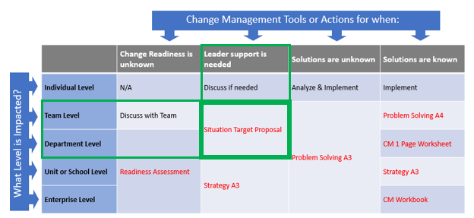

Once the sections of the tool are filled out, they can be presented to the leader in an email, memorandum, or PowerPoint presentation. The template and instructions for each section are below. On subsequent pages we have provided several examples:
Situation
- In this section, describe the current situation in as much detail as possible. This should include relevant information about the context, any relevant parties or factors, and any relevant constraints or limitations.
Target
- In this section, describe the desired outcome or goal of the decision. Be as specific as possible and consider what a successful outcome would look like.
Proposal
- In this section, describe the proposed course of action to achieve the desired outcome. This should include a detailed plan, as well as any potential risks or challenges that may need to be addressed. Depending on the nature of the project, simple high-level milestones may be sufficient
Examples for absenteeism, assigning teaching aides, and turnover proposals on next pages:

EXAMPLE 1:

Situation:
- The current situation is that our company is struggling with high rates of employee absenteeism, which is leading to reduced productivity and increased costs. Many of our employees have cited poor work-life balance and high levels of stress as reasons for taking time off.
Target
- The desired outcome or goal of the decision is to improve employee morale and work-life balance, and reduce absenteeism.
Proposal:
- The proposed course of action is to implement a new flexible work policy that will allow employees to work from home or adjust their work hours to better fit their personal schedules. We will also provide training on stress management and work-life balance, and establish an employee assistance program to provide support for employees who are struggling with personal issues. Potential risks and challenges include the possibility of reduced productivity if employees are not able to work as effectively from home, or if they take advantage of the flexible work policy. To mitigate these risks, we will provide guidelines and support for employees to ensure that they are able to work effectively, and we will monitor the impact of the new policy on productivity.

EXAMPLE 2:
Situation:
- We have been receiving complaints from faculty members about the current process of assigning teaching aides to classes. They say that it is process is cumbersome and time-consuming, and it often results in teaching aides being assigned to classes at the last minute.

Target
- The target of this proposal is to improve the process of assigning teaching aides to classes in order to make it more efficient and effective. During the project we will capture how long this takes; we don’t currently know.

Proposal
- The proposal is to design and implement a simple in-house online system for assigning teaching aides to classes. The system would allow faculty members to request teaching aides for their classes and would allow teaching aides to express their availability and preferences. The system would match teaching aides with classes based on their availability and preferences, and would provide notifications to all parties involved. The system would also allow the academic unit to track and manage the assignments, making the process more efficient and transparent.

EXAMPLE 3:
Situation:
- The current situation is that our team is struggling with high levels of turnover, and we are unable to retain experienced employees. Many of our employees have cited lack of career growth opportunities and lack of support from management as reasons for leaving.
Target
- The desired outcome or goal of the decision is to improve employee retention and satisfaction, and provide support for career growth
Proposal
- The proposed course of action is to implement a new mentoring program that will pair experienced employees with newer staff members, and provide training and support for managers to help them provide better support and guidance to their teams. We will also establish a career development plan for each employee, and provide opportunities for training and professional development. Potential risks and challenges include the possibility of the mentoring program not being effective, or managers not fully embracing the new support and training opportunities. To mitigate these risks, we will carefully select and train the mentors, and provide ongoing support and monitoring of the program. We expect to see improved employee retention and satisfaction as a result of these changes.

